

**Spring 2024**

Submitted by: **Hassan Zaib Jadoon**

Registration No: **22pwsce2144**

Class Section: **A**

“On my honor, as student of University of Engineering and Technology, I have neither given nor received unauthorized assistance on this academic work.”

Submitted to:

**Engr. Abdullah Hamid**

15 April 2024

**Department of Computer Systems Engineering**

**University of Engineering and Technology, Peshawar**

**Operating Systems Lab 5: Process Creation and Execution**

**Objectives:**

This lab describes how a program can create, terminate, and control child processes. There are a few distinct operations involved: creating a new child process, and coordinating the completion of the child process with the

original program.

**Tasks:**

**Task 1:**

Run the following program twice. Both times as a background process, i.e., suffix it with an ampersand "&". Once both processes are running as background processes, view the process table using ps -l UNIX command. Observe the process state, PID (process ID) etc. Repeat this experiment to observe the changes, if any. Write your observation about the Process ID and state of the process.  
  
**Code:**

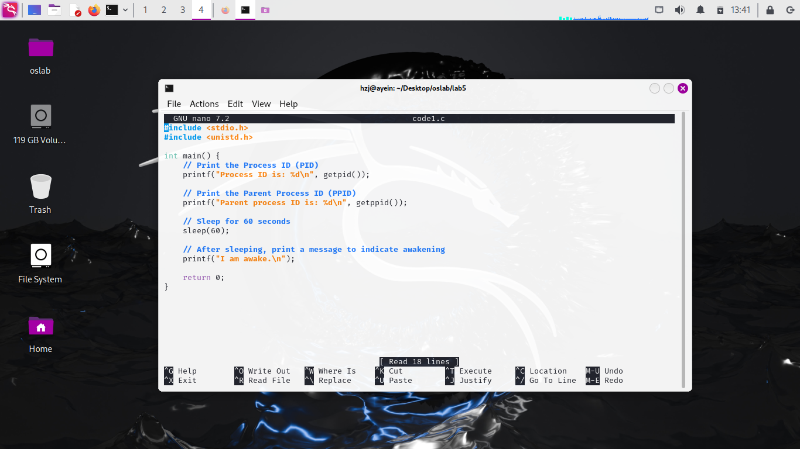

**Output:**

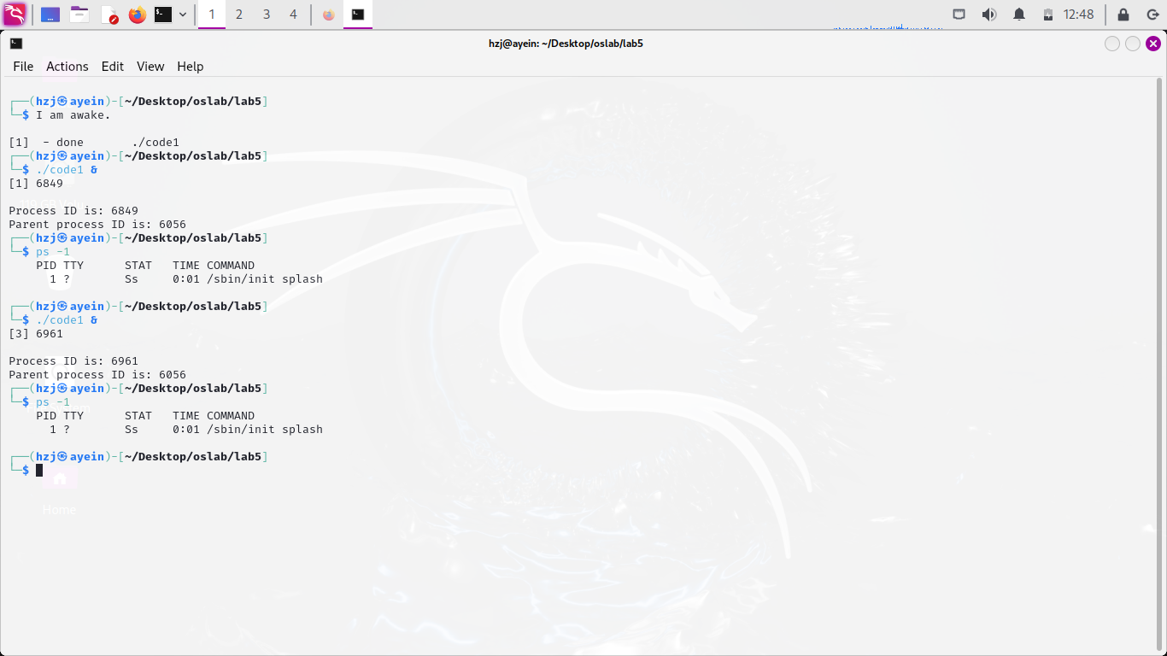

**Task 2:**

Run the following program and observe the number of times and the order in which the print statement is executed. The fork () creates a child that is a duplicate of the parent process. The child process begins from the fork (). All the statements after the call to fork () are executed by the parent process and by the child process. Draw a family tree of processes and explain the results you observed.

**Code:**

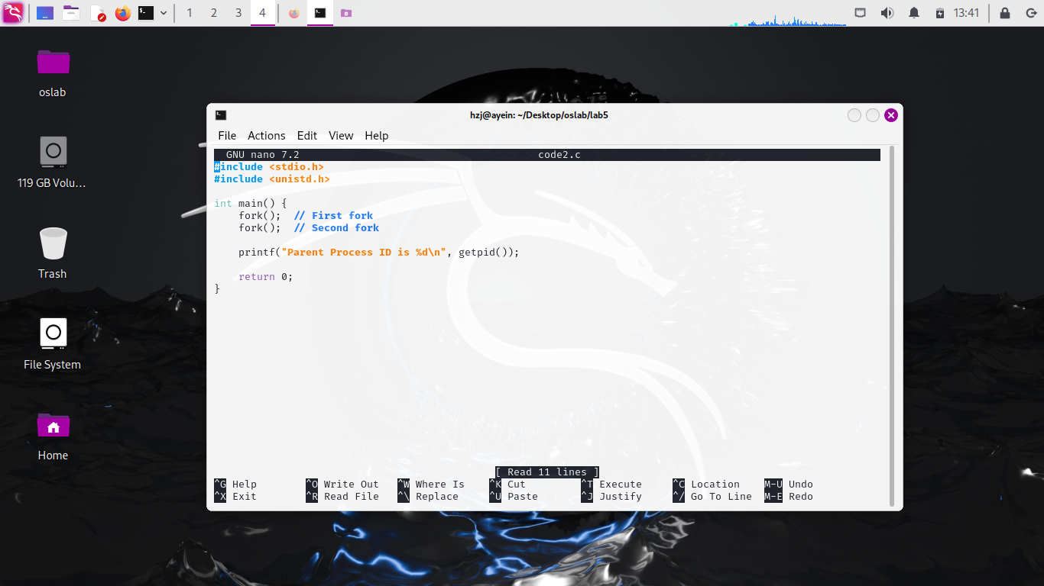

**Output:**

**Task 3:**

**Run the following program and observe the result of time slicing used by UNIX.**

**Code:**

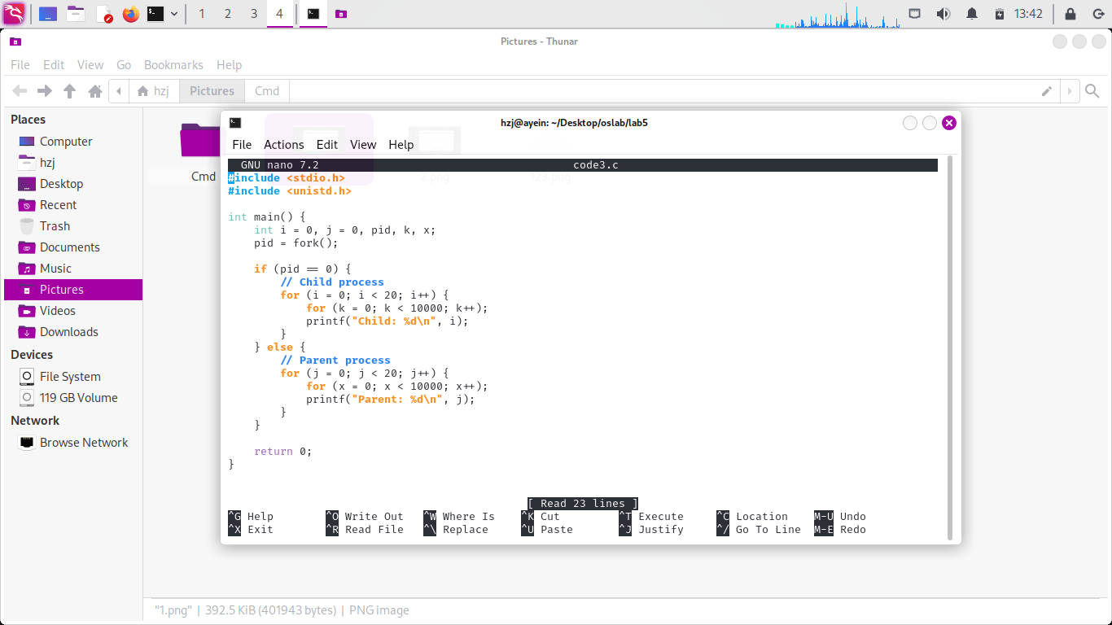

**Output:**

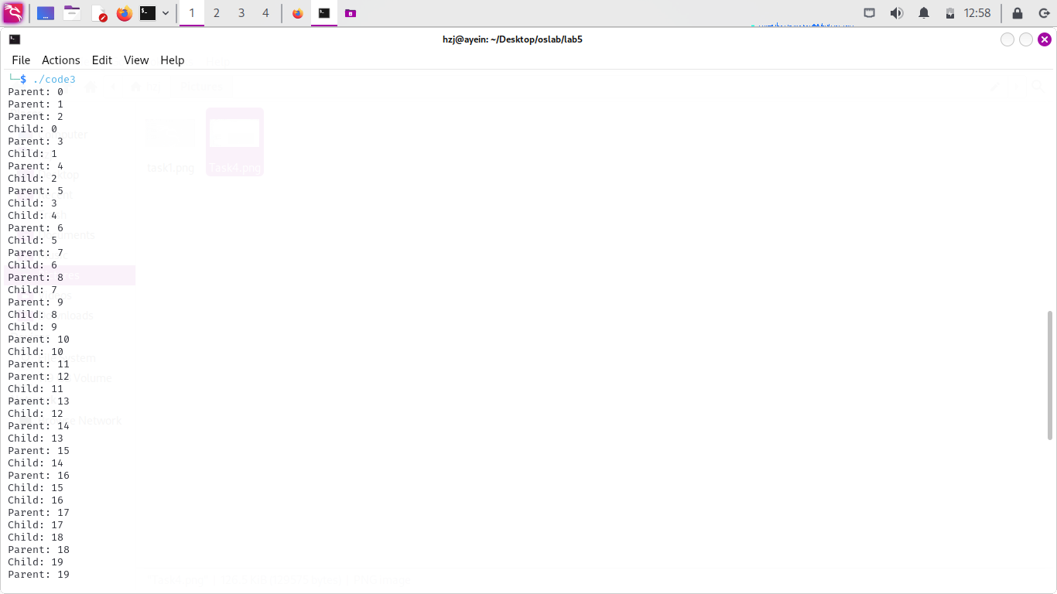

**Task 4:**

**Create process fan as shown in figure 1 (a) and fill the figure 1 (a) with actual IDs.**

**Code:**

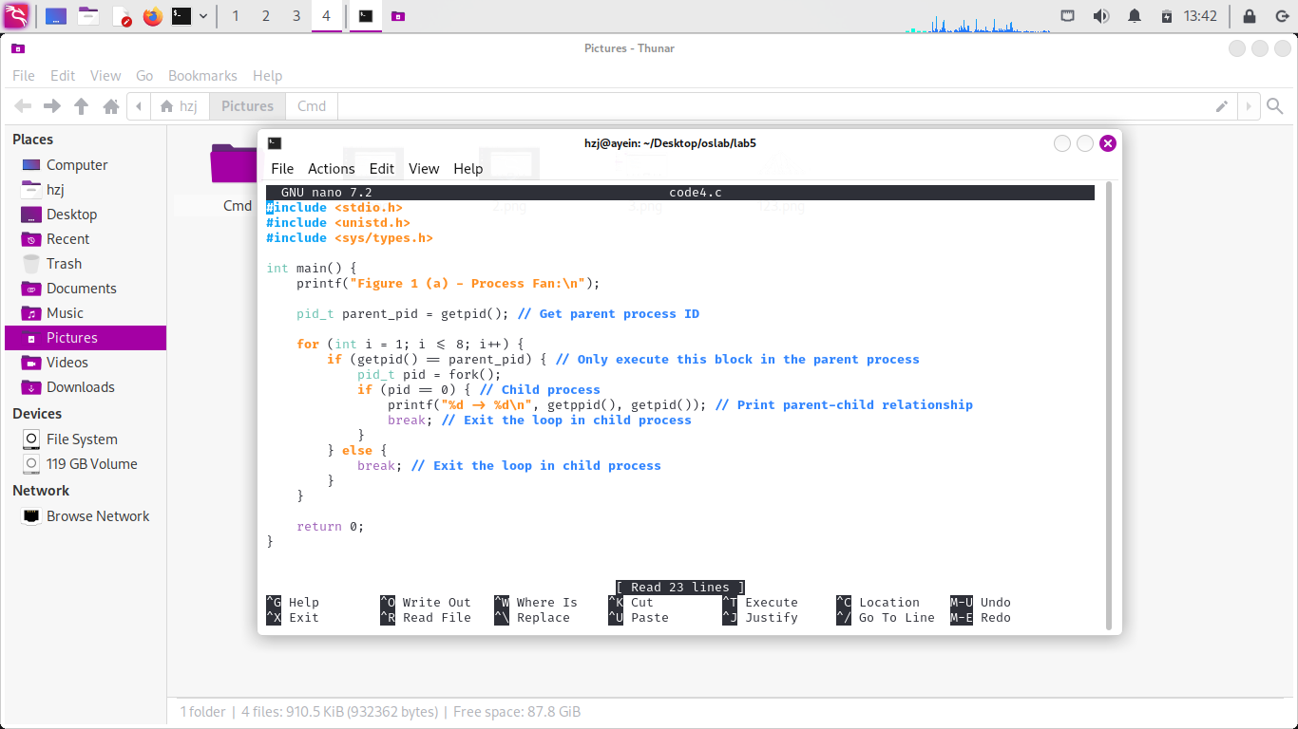

**Output:**

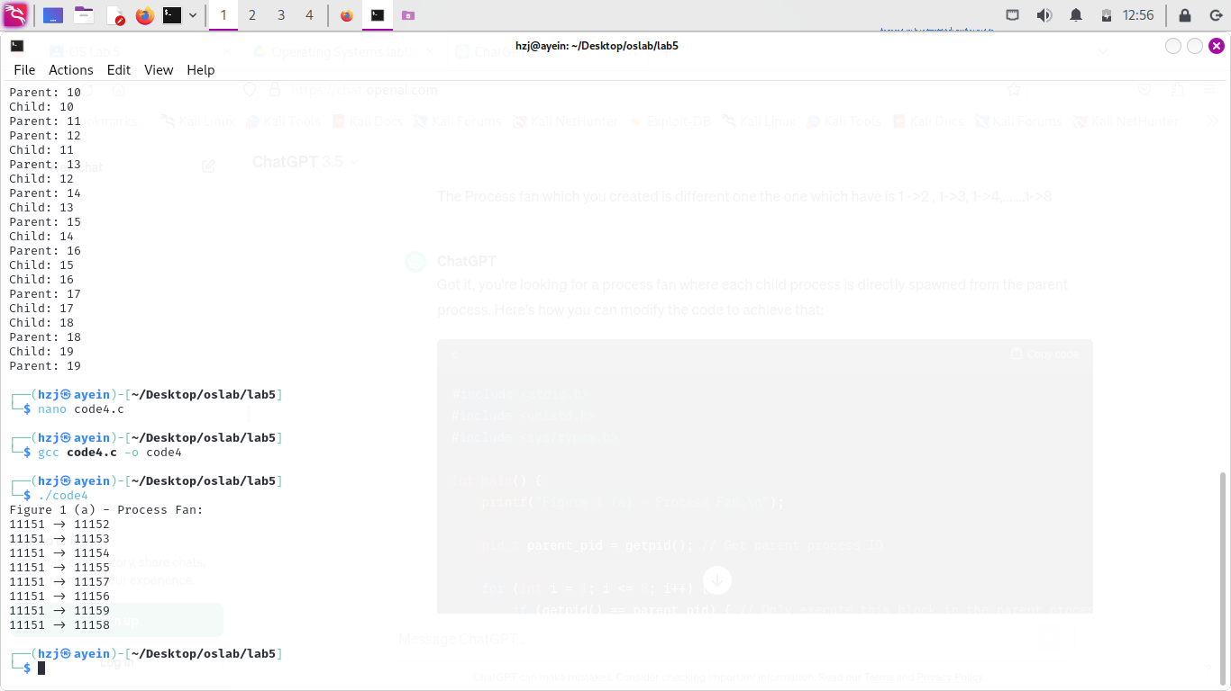

The outputs shows actual id’s.

**Task 5:**

**Create process chain as shown in figure 1(b) and fill the figure 1 (b) with actual IDs.**

**Code:**

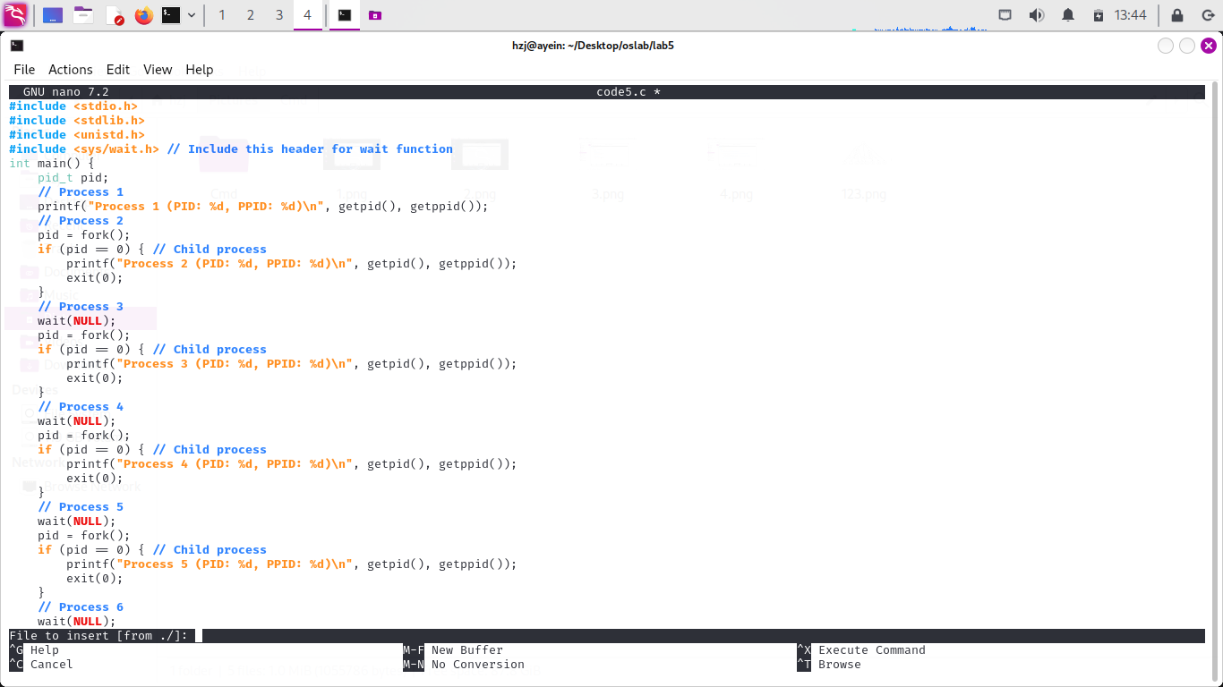

**Output:**

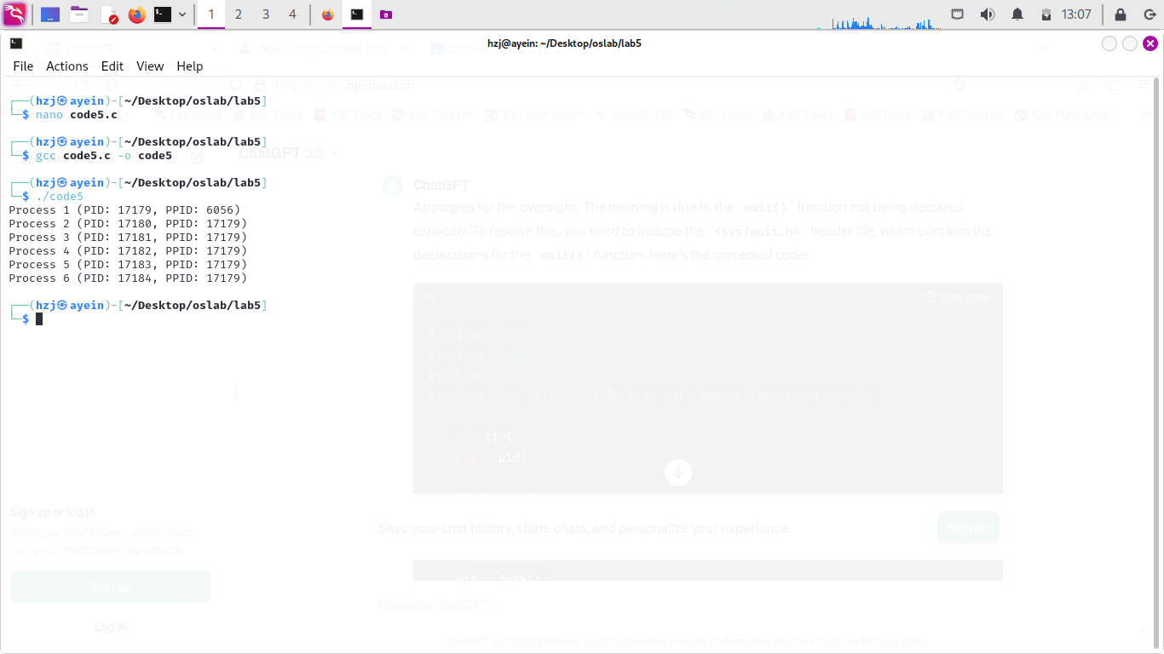

The above outputs show original id’s.

CSE 302L: Operating Systems Lab LAB ASSESSMENT RUBRICS

|  |  |  |  |  |
| --- | --- | --- | --- | --- |
| **Marking Criteria** | **Exceeds expectation (2.5)** | **Meets expectation (1.5)** | **Does not meet expectation (0)** | **Score** |
| **1. Correctness** | Program compiles (no errors and no warnings).  Program always works correctly and meets the specification(s).  Completed between 81-100% of the requirements. | Program compiles (no errors and some warnings).  Some details of the program specification are violated, program functions incorrectly for some inputs.  Completed between 41-  80% of the requirements. | Program fails to or compile with lots of warnings.  Program only functions correctly in very limited cases or not at all.  Completed less than 40% of the requirements. |  |
| **2. Delivery** | Delivered on time, and in correct format (disk, email, hard copy etc.) | Not delivered on time, or slightly incorrect format. | Not delivered on time or not in correct format. |  |
| **3. Coding Standards** | Proper indentation, whitespace, line length, wrapping, comments and references. | Missing some of whitespace, line length, wrapping, comments or references. | Poor use of whitespace, line length, wrapping, comments and references. |  |
| **4. Presentation of document** | Includes name, date, and assignment title.  Task titles, objectives, output screenshots included and good formatting and excellently organized. | Includes name, date, and assignment title. Task titles, objectives, output screenshots included and good formatting. | No name, date, or assignment title included.  No task titles, no objectives, no output screenshots, poor formatting. |  |

**Instructor:**

Name: Engr. Abdullah Hamid Signature: